EVENT VENUE Address:
北京天通苑黄河京都会议中心 3号楼 北京市昌平区东小口镇太平庄中街1号
Beijing Huanghe Jingdu Conference Center The Number Third Building
No. 1, Taipingzhuang Middle Street, Dongxiaokou Town, Changping District, Beijing

Showing in the map following, The red square is the conference venue. The yellow line square is the metro line 5 Tiantongyuan South station,

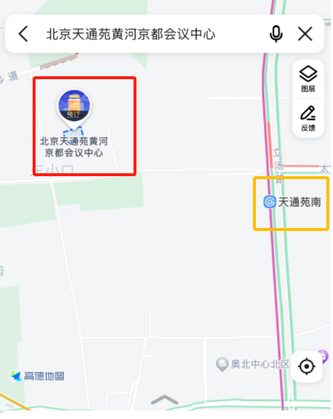
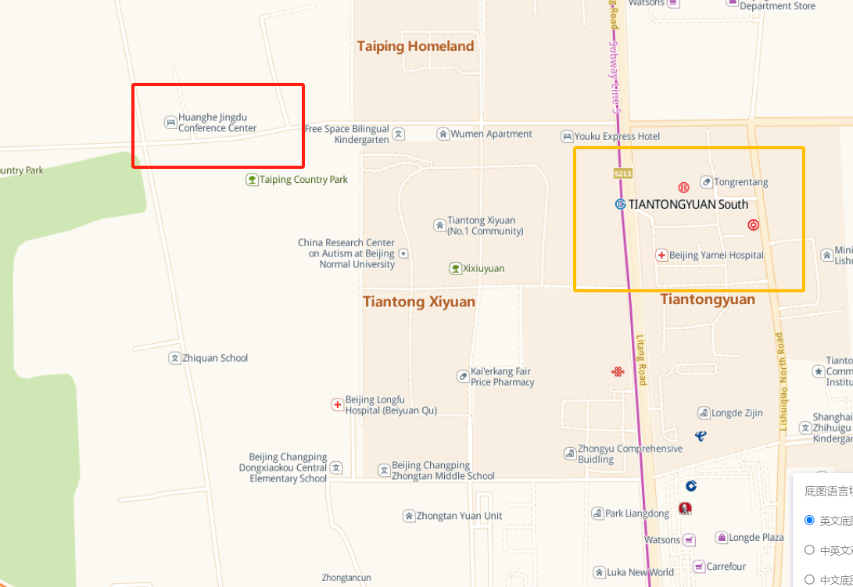

The distance from metro line 5 Tiantongyuan South station to the venue is 1.5 kilometers, taking about 23 minutes walking

As showing following:
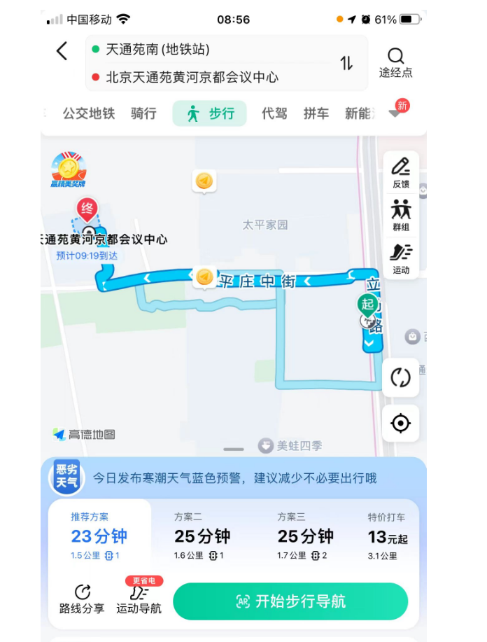

The nearest international airport is 北京首都国际机场Beijing Capital International Airport as showing in the following: The gray square is the Beijing Capital International Airport, The yellow line square is the metro line 5 Tiantongyuan South station,

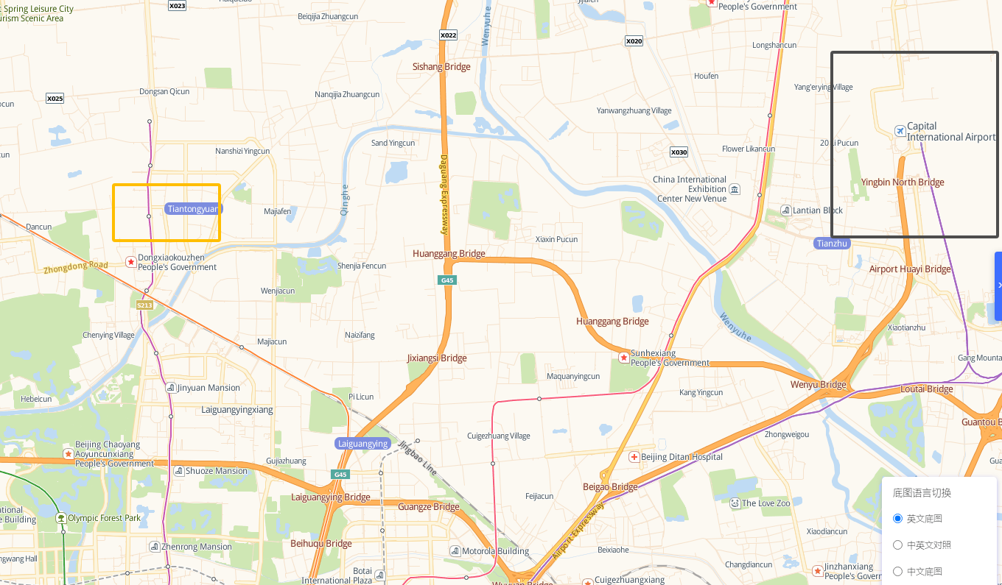
In taking a taxi, it will take about 50 mintues reaching the Beijing Huanghe Jingdu Conference Center, the price will be from 59-80 RMB
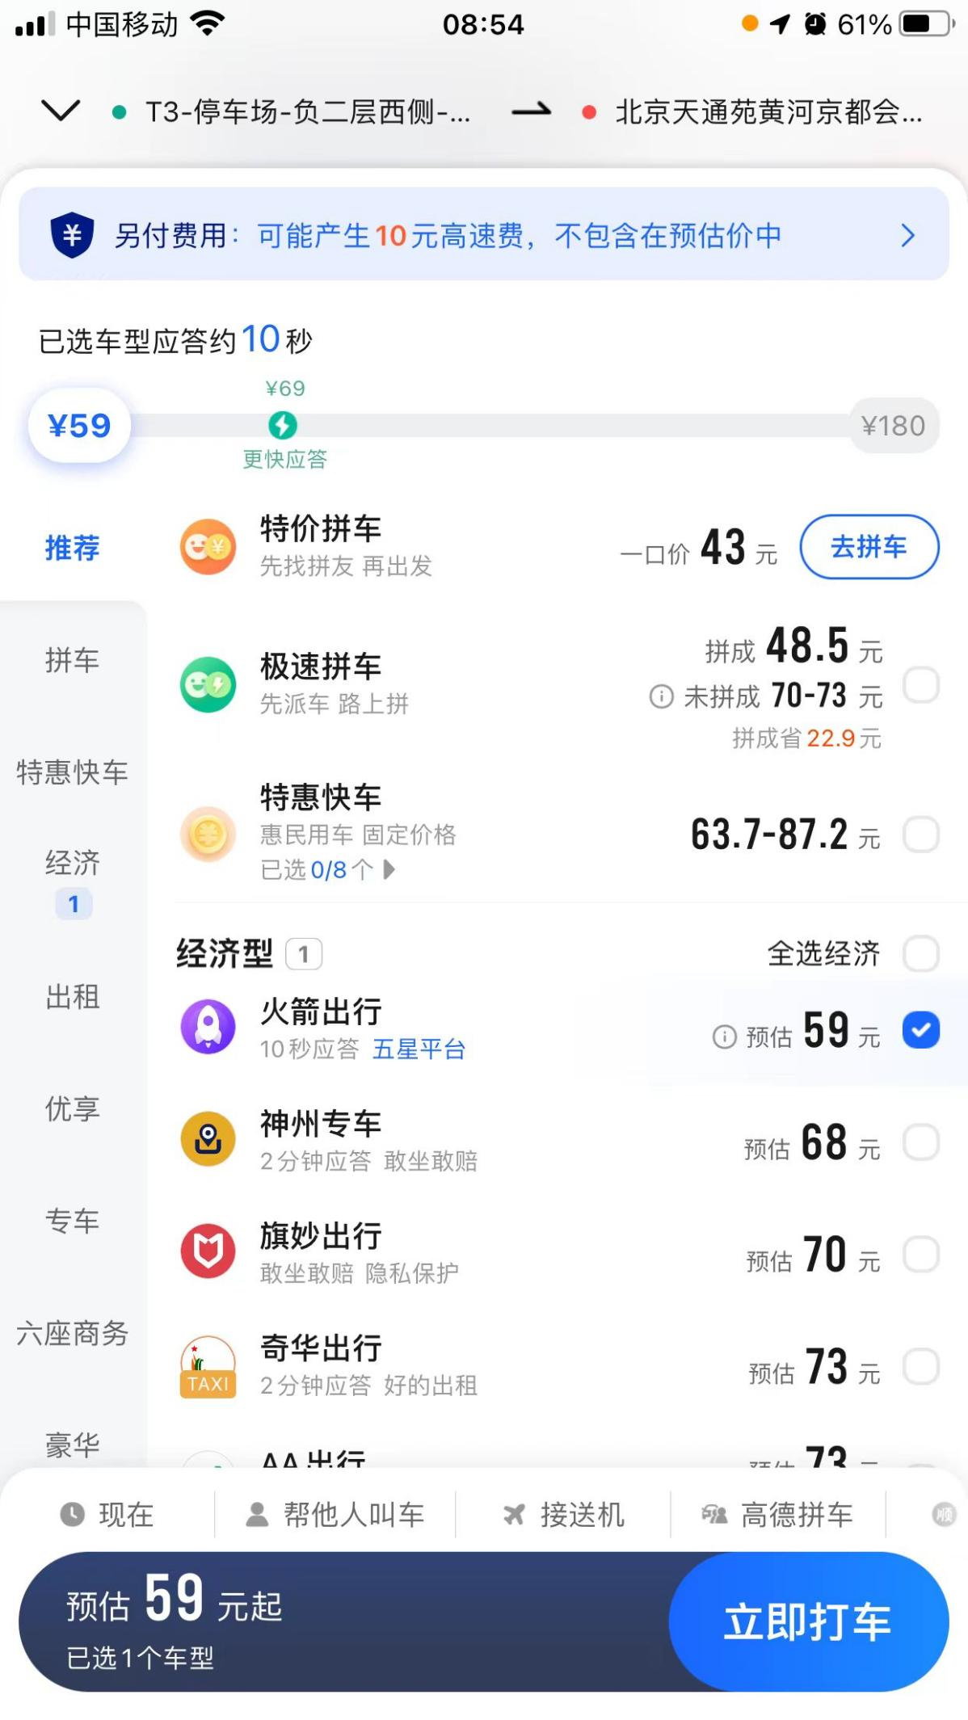

In taking the Beijing metro systems, it will take about 1.5 hours, the price will be around 30 RMB, as showing following:

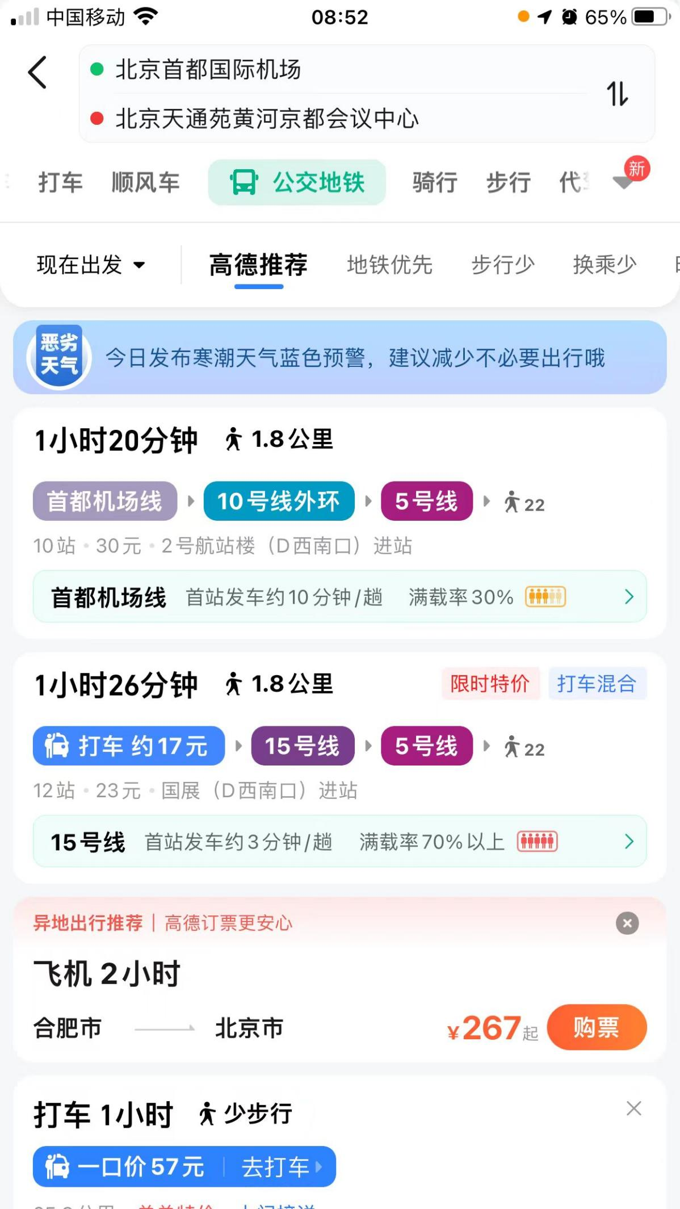

We have co-operation with the conference venue in hotel. The price is RMB 350 or USD 50 for standard room every night,RMB 450 or USD 70 for three beds room, both breakfast included.You can book hotel in the venue through us. In booking the hotel through us, you need to pay us.As there is only 243 rooms in the venue hotel, not enough for the attendees, if you plan in staying in the venue hotel, please contact us the earlier the better.
The venue hotel is a four star hotel.
Hotel Room Pictures as following
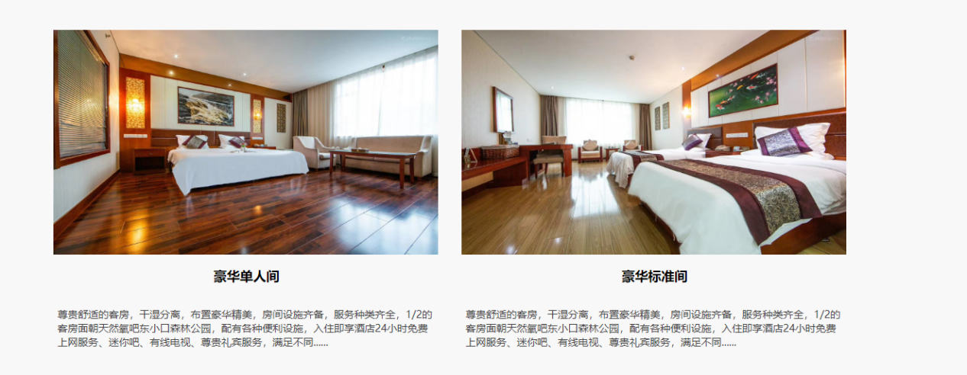

4月10日晚大会将在会议中心给部分演讲及参会嘉宾安排圆桌晚宴。 未受邀代表可以自费参加。 费用 RMB 100 元一位 如有兴趣，请联系 13817254690 微信同号 预定。预定截至日期：4月1日。
On the evening of April 10, 2026, the conference will arrange round-table dinner for some speakers and guests in the conference center. Delegates who are not invited can attend at their own expense. The cost is RMB 100 per person or USD 15 each person. If interested, Please contact0086- 13817254690, WeChat ID：13817254690 , to make a reservation.Reservation deadline: April 1.

Our overseas USD account is:
DIRECT BANK TRANSFER - Please make payment by TT remmitence to our bank account as below:
Beneficiary Name: Shanghai Guang Mao Exhibition Services Inc
Address:2/F.No.58Lane158.Baocheng Road.Minhang District Shanghai.201100, P.R.China
Bank Account: 09032714040001255
Bank Name AGRICULTURAL BANK OF CHINA
Bank Address THE JIN YU PLAZA 100 XISANHUAN BEILU HAIDIAN DISTRICT BEIJING
SWIFT CODE: ABOCCNBJ090

Our overseas EURO account is:
DIRECT BANK TRANSFER - Please make payment by TT remmitence to our bank account as below:
Beneficiary Name: Shanghai Guang Mao Exhibition Services Inc
Bank Account: 09032738040000819
Bank Name: AGRICULTURAL BANK OF CHINA
Bank Address: THE JIN YU PLAZA 100 XISANHUAN BEILU HAIDIAN DISTRICT BEIJING
SWIFT CODE ABOCCNBJ090
NOTE: Full payment of the invoice amount is required. Remitting bank charges or agent bank charges, any local or withholding taxes are
EXCLUSIVE of this invoiced amount.

Our domestic RMB account:
开户行中国农业银行股份有限公司上海水清南路支行
户名上海广贸会展服务有限公司
帐号 0341 6900 0400 39005

You can also contact the hotel for room booking, contacts as following:
Please contact the hotel manager 张文慧经理0086-18519198567微信, wechat ID:18519198567 email: 870381153@qq.com
You can also find hotel in that area yourself.

There is no pick up separately. Attendees need to go to the venue themselves
大会不安排接送。 参会人员需自行前往会场
Conference language is English and Chinese. Speech can be given in both language.

大会资料邮寄地址：北京市昌平区天通苑南黄河京都会议中心3号楼前台张文慧 18519198567 请标明 广贸会展活动资料

Mailing address of conference materials: 北京天通苑黄河京都会议中心 3号楼 北京市昌平区东小口镇太平庄中街1号
Beijing Huanghe Jingdu Conference Center The Number Third Building
No. 1, Taipingzhuang Middle Street, Dongxiaokou Town, Changping District, Beijing
Receiver : Zhang Wenhui 0086-18519198567
Please indicate the information： materials for Guangmao Conference 广贸会展活动资料

特装展位展厅限高 4米 搭建进场需要给场馆方缴纳2000元押金。撤展后场馆退还。 场馆联系人：张文慧 18519198567
The exhibition hall for special raw space booth has a height limit of 4 meters. A deposit of 2,000 yuan must be paid to the venue for booth setup entry. The deposit will be refunded by the venue after the booth dismantled. Venue contact: Zhang Wenhui 0086-18519198567

展位搭建及租赁合作方：13261929186张亚丽
Booth construction and leasing partner: 13261929186 Zhang Yali

The following APP is widely used in China for instant contacts and payment:

https://www.wechat.com/en/

The organizers wehcat ID: 13817254690
Or scan the following to add



